1. Coffee Stands

<https://openverse.org/image/decc9a88-98e0-4ca9-aebc-b4f78fb6f1f4?q=coffee%20stand>

<https://openverse.org/image/decc9a88-98e0-4ca9-aebc-b4f78fb6f1f4?q=coffee%20stand>

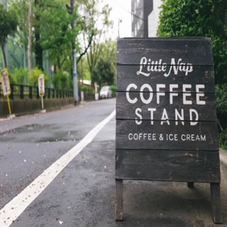

2. Silly Putty

<https://openverse.org/image/daeffe3e-09e4-4589-b878-816a46755b98?q=silly%20putty>

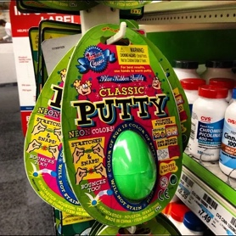

3. Snap-on Tools

<https://openverse.org/image/aca92468-b7bf-4694-9abe-fa61812c6e01?q=snap%20on%20tool>

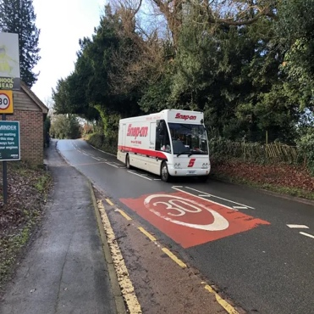

4. HomeWell

<https://openverse.org/image/f68fdb69-58cd-4647-9187-86b60b7b7072?q=elderly>

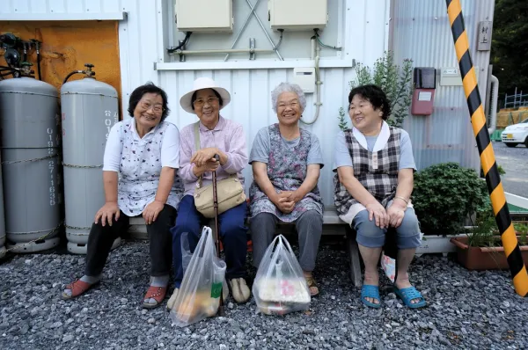

6. 7-Eleven

https://live.staticflickr.com/3723/13177542914_895807ba05_b.jpg

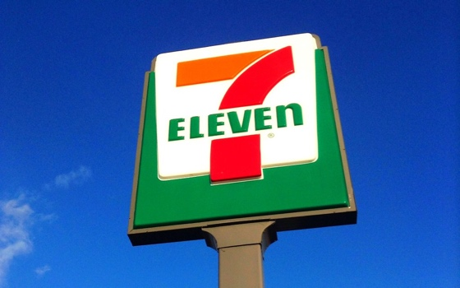

7. Jack in the Box

https://api.openverse.engineering/v1/images/8072d7e3-051e-450d-b64c-ad3d483d46dd/thumb/

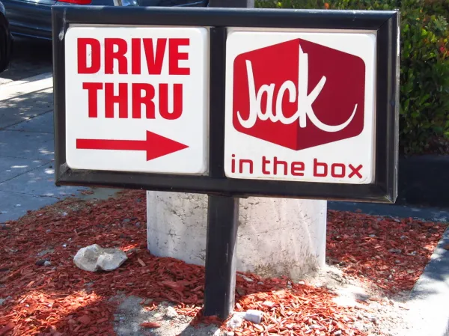

8. Franchise Sign

<https://live.staticflickr.com/7148/6425505173_c806951196_b.jpg>

